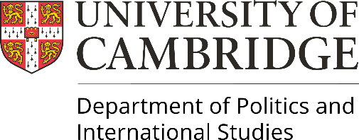 | Professor Jude Browne  Head of Department

Re: POLIS Student Health and Safety Policy for Unregulated Accommodation

The Department of Politics and International Studies (POLIS) is committed to the highest standards of education and research. With this comes the responsibility for the health and safety of the staff and students who may be affected by the Department’s activities, especially whilst outside of Cambridge on University business.

Whilst travelling on University business, suitable regulated accommodation should always be used where available. However, the Department of POLIS acknowledges there will be exceptions where Airbnb could be the only practical solution. For these purposes please ensure you have knowledge of the responsibilities for managing the risks, that reasonable risk assessment steps are taken, and the risk of exposure to the Department, of costs not covered by insurance, are minimized.

By signing this statement, you are affirming that you have taken all reasonable steps necessary to consider the risk of your unregulated accommodation. This includes a risk assessment listing the safety measures already in place in the accommodation as well as any other measures you have put in place in order to manage health and safety risks.

It is the duty of every student to take care of his or her own health and safety whilst on his or her study placement, especially whilst in unregulated accommodation. Students have a duty to bring to the attention of the Department any failings in the arrangements made for health and safety whilst in their unregulated accommodation.

Name:

Date:

Signature:

