MPhil in International Relations — Lent term 2021
Geopolitics 1555-1763

The course will show how some of the themes which dominate international politics today have their roots in the old European balance of power as it evolved into the global system we know today: the German question, British exceptionalism, colonialism, maritime versus continental hegemony, the Muslim threat, conditional sovereignty, the Rise of Russia, slavery, and humanitarian intervention. Each seminar will involve the discussion of primary sources as well as secondary literature.

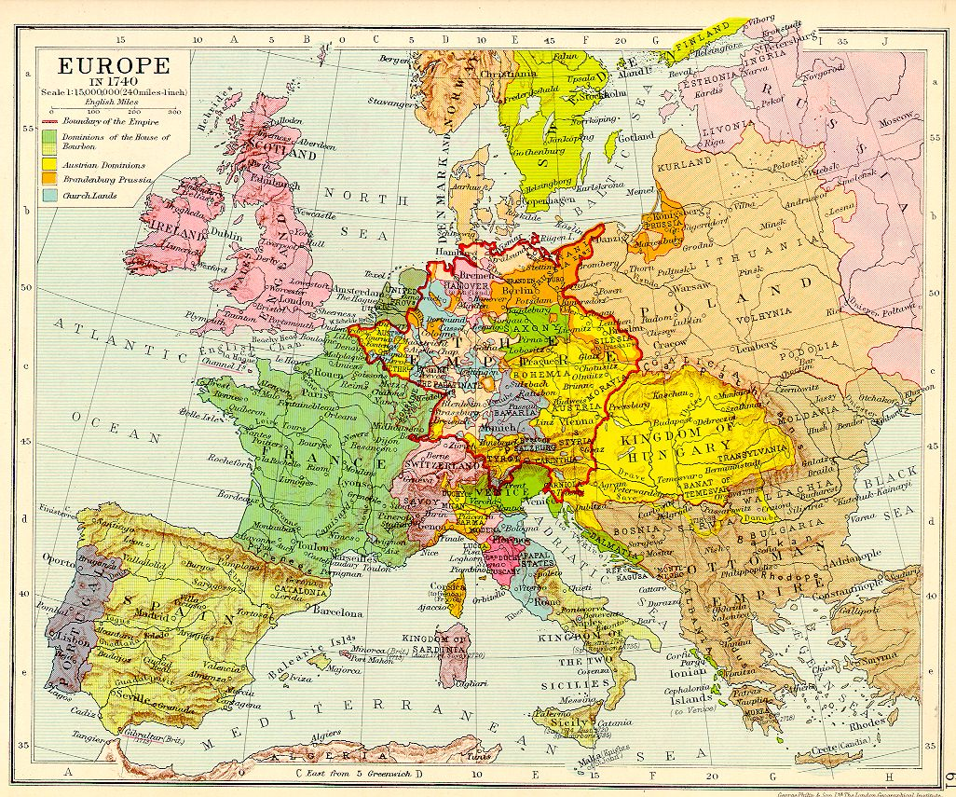

Preparatory Reading
Unless you have a background in early modern European history, it is important that you tackle some of this background reading in advance, and alongside the reading listed for individual lectures/seminars. It would also be very helpful if you invested in a historical atlas.

H.M. Scott and Derek McKay, The Rise of the Great Powers, 1648-1815 (London, 1983)
Paul Kennedy, The rise and fall of the Great Powers: Economic change and military conflict from 1500 to 2000 (London, 1988).
Brendan Simms, Europe: The Struggle for Supremacy (New York, 2013)
Brendan Simms, Britain’s Europe. A thousand years of conflict and cooperation (London, 2016).
Peter H. Wilson, The Holy Roman Empire: A Thousand Years of Europe’s History (London, 2016).
Joachim Whaley, Germany and the Holy Roman Empire, 1495-1806 (Oxford, 2011)
Edward Mead Earle, with Gordon A. Craig and Felix Gilbert, eds., Makers of Modern Strategy: Military Thought from Machiavelli to Hitler (Princeton, N.J.: Princeton University Press, 1971).
Richard Neustadt and Ernest May, Thinking in Time: The Uses of History for Decision Makers, (New York, 1986).
Henry Kissinger, Diplomacy (New York and London, 1994).
Useful journals to consult include: International History Review, Historical Journal, Diplomatic History, Diplomacy and Statecraft.
For various articles and reviews see also: New York Review of Books, London Review of Books, Times Literary Supplement, Foreign Affairs, The National Interest.

*

LECTURES AND SEMINARS
The primary sources listed here are all available on Moodle. Some of the secondary sources are also on Moodle; those that aren’t are for additional reading.

Lecture 1. 1555-1600
This lecture will provide a thematic outline of the emergence of the multipolar European state system. It will address developments which remained important for many centuries, such as the great rivalry between France and the House of Habsburg, the centrality of the Holy Roman Empire to the state system, the Protestant Reformation, and the European conquest of the New World. During the second half of the sixteenth century, European geopolitics was characterised by several regional rivalries or balances which formed part of the overall balance of power. These included the Franco-Habsburg rivalry and the Spanish-Dutch conflict in the west, the struggle for supremacy in the Baltic, and the Ottoman threat in south-west Europe. Where all these rivalries and conflicts intersected was the Holy Roman Empire at the centre of the European system. Its members had successfully forestalled serious sectarian civil war (unlike the French) at the Peace of Augsburg (1555), which established effective confessional co-existence for several decades. However, by the end of the century, growing confessionalisation and religious strife was beginning to paralyse this crucial polity at the heart of Europe.

Primary Sources
Stephanus Junius Brutus, Vindiciae contra tyranos [1579], ed., transl. George Garnett (Cambridge, 1994).
Documents in in Calendar of State Papers Foreign, Queen Elizabeth:
- 'Elizabeth: April 1561, 21-30', Document 151, Throckmorton to Elizabeth I, 29 April 1561: British History Online http://www.british-history.ac.uk/cal-state-papers/foreign/vol4/pp73-90 (Vol. 4 Cal. State Papers For.)
- 'Elizabeth: March 1562, 1-10', document 924, Throckmorton to Elizabeth I, 6 March 1562: British History Online http://www.british-history.ac.uk/cal-state-papers/foreign/vol4/pp542-553 (Vol. 4 Cal. State Papers For.)
- Elizabeth I to commissioners, December 1587, in Sophie Crawford Lomas and Allen B. Hinds (eds.), Calendar of State Papers Foreign: Elizabeth, Volume 21, Part 3, April-December 1587 (London, 1929), 474-75, British History Online http://www.british-history.ac.uk/cal-state-papers/foreign/vol21/no3.

Treaty of Chambord, 1552 (August von Druffel, ed., Briefe und Akten zur Geschichte des sechzehnten Jahrhunderts, vol. 31546–1552. No. 902, pp. 340-48 – translation).
Alberico Gentili, De iure belli libri tres [1588/98], ed., transl. J.C. Rolfe (Oxford, 1933), I, ch. 16.
Jean Bodin, The Six Bookes of a Commonweale [1576], ed. K.D. McRea (Cambridge, 1962), p. 632f
Religious Peace of Augsburg 1555, transl.
William of Orange’s Apologia 1580

Secondary Sources
R.B. Wernham, ‘Elizabethan War Aims and Strategy’, in S.T. Bindoff, J.Hurstfield, and C.H. Williams (eds.), Elizabethan Government and Society: Essays presented to Sir John Neale (London, 1961), 340-68
Peter H. Wilson, Europe’s Tragedy. A New History of the Thirty Years War (London, 2009), chs. 2-6.
D.J.B. Trim, ‘“If a prince use tyrannie towards his people’: interventions on behalf of foreign populations in early modern Europe’, in in Brendan Simms and David Trim (eds.) Humanitarian Intervention: A History (Cambridge, 2011).
Wallace T. MacCaffrey, ‘The Newhaven Expediton’, 1562-1563, The Historical Journal, 40, 1 (1997), 1-21.
Christopher W. Close, State Formation and Shared Sovereignty. The Holy Roman Empire and the Dutch Republic, 1488–1696 (Cambridge 2021), chs. 4-5.
Palmira Brummett, ‘Ottoman expansion in Europe, ca. 1453–1606’, in Suraiya N. Faroqhi and Kate Fleet (eds.), The Cambridge History of Turkey vol 2 (Cambridge, 2013).
Kate Fleet, ‘Ottoman expansion in the Mediterranean’, in ibid.
Joachim Whaley, Germany and the Holy Roman Empire (Oxford, 2011), vol. 1, chs. 27-32.
Geoffrey Parker, The Grand Strategy of Philipp II (New Haven and London, 1998).
John H. Elliott, ‘A Europe of Composite Monarchies’, Past & Present, 137 (1992), pp. 48-71.
Geraldine McKendrick, ‘To defend your empire and the faith. Advice on a global strategy offered c.1590 to Philip, King of Spain and Portugal, by Manoel de Andrada Castel Blanco’

Lecture 2. 1600-1634
Growing religious and political tensions within the Empire from the turn of the century and the confluence of European rivalries in central Europe explain why a local rebellion in a peripheral territory of the Empire could rapidly escalate into the greatest conflict of early modern Europe, the Thirty Years War (1618-1648). This lecture will address the origins of the war and its first half, including the interventions by Denmark and Sweden (1625 and 1630).

Primary Sources
Acceptance of the Bohemian crown by Elector-Palatine Frederick V, 1619 (Peter H. Wilson, ed., The Thirty Years War: A Sourcebook, 47ff).
Swedish Manifesto of Gustavus Adolphus justifying the intervention in the war, 1630 (ibid, 122ff).
Hugo Grotius, De Iure Belli ac Pacis (1625), Book II, ch. 25.8
House of Commons declaration for the recovery of the Palatinate, 4 June 1620

Secondary Sources
Peter H. Wilson, ‘The Causes of the Thirty Years War 1618-48’, English Historical Review, vol 123, no. 502 (2008), 554-586.
Pärtel Piirimäe, ‘Just war in theory and practice: the legitimation of Swedish intervention in the Thirty Years War’, The Historical Journal, 45, no. 3 (2002), 499-523.
Peter H. Wilson, ‘New Perspectives on the Thirty Years War’ – review article
Christopher W. Close, State Formation and Shared Sovereignty. The Holy Roman Empire and the Dutch Republic, 1488–1696 (Cambridge 2021), chs. 6-7.
Peter Brightwell, ‘Spain and Bohemia. The Decision to intervene, 1619’, European Studies Review 12 (1982), 117-41.
G.P. van Nifterik, ‘Religious and humanitarian intervention in 16th and early 17th C Legal thought’, in Randall Lesaffer and Georges Macours (eds.), Sovereignty and the Law of Nations 16th—18th centuries), in Iuris Scripta Historica, 20 (2006), 35-60.
Peter H. Wilson, ‘The Thirty Years War as Europe’s constitutional crisis’.
Peter H. Wilson, Europe’s Tragedy. A New History of the Thirty Years War (London, 2009).
Joachim Whaley, Germany and the Holy Roman Empire (Oxford, 2011), vol. 1, chs. 33-36, 48-53.
Kalina Vanderlei Silva, ‘A sugar plantation lord in the service of the Spanish King: Portuguese America and the Universal Monarchy in the 17th Century’ Estudios Ibero-Americanos 40, no. 2 (2014), 348-366.

Lecture 3. 1635-1660
This lecture will cover the second half of the Thirty Years War, a stage when it became irreversibly internationalised, following the French intervention against Spain and the Holy Roman Emperor in 1635. The lecture will focus on the Peace of Westphalia, a result of the first multilateral peace congress, which ended most of the numerous sets of conflict constituting the Thirty Years War (the Franco-Spanish war continued and renewed war in the Baltic erupted in the later 1650s). The aftermath of Westphalia will also be discussed, including the successful application of its mutual guarantee clauses as a system of collective security for central Europe.

Primary Sources
Instructions to the Imperial, French, and Swedish envoys to the Congress of Westphalia (Wilson, Sourcebook, ch. 17; and Acta Pacis Westphalicae)
Treaties of Münster and Osnabrück, 1648: Clive Parry, ed., Consolidated Treaty Series (vol. 1, Dobbs Ferry, 1969)

Secondary Sources
Christoph Kampmann, ‘Peace Impossible? The Holy Roman Empire and the European State System in the Seventeenth Century’, in Olaf Asbach and Peter Schröder, eds., War, State and International Law in Seventeenth Century Europe (Farnham, 2009), pp. 197-210.
Ronald G. Asch, The Thirty Years War: The Holy Roman Empire and Europe, 1618-1648 (Harlow, 1997)
Andreas Osiander, ‘Sovereignty, international relations, and the Westphalian myth’, International Organization 55, no. 2 (2001): 251–287.
Derek Croxton, ‘The Peace of Westphalia of 1648 and the origins of sovereignty,' International History Review 21, no. 3 (1999): 569–591
Christopher W. Close, State Formation and Shared Sovereignty. The Holy Roman Empire and the Dutch Republic, 1488–1696 (Cambridge 2021), ch. 8.
Derek Croxton, The Last Christian Peace.
Derek Croxton, Peacemaking in Early Modern Europe: Cardinal Mazarin and the Congress of Westphalia 1643-48 (Selinsgrove, 1999).

Lecture 4. 1660-1688
By 1660 Europe was finally peace with the end of the last major constituent conflict of the Thirty Years War (the Franco-Spanish war, 1635-59) and the conclusion of the Peace of Oliva (1660) in the North. The peace soon broke down with the rise of French King Louis XIV’s policy of aggressive geopolitical expansion towards the Low Countries and Germany from the late 1660s. This lecture will explore the early wars of Louis XIV, including the War of Devolution (1667-68), the Dutch War (1672-78), and the War of Reunions (1683-84).

Primary sources
Sardan de Paul - Europe a slave, unless England break her chains
Misc. Parliamentary debates and statements, 1677-78, 1680

Secondary Sources
Philip McCluskey, ‘From Regime Change to Réunion: Louis XIV’s Quest for Legitimacy in Lorraine, 1670–97,’ English Historical Review, Vol. 126 No. 523, (2011).
Georges Livet, ‘Louis XIV and the Germanies’, in Ragnhild Hatton, ed., Louis XIV and Europe (London, 1976).
Derek McKay, ‘Small power diplomacy in the age of Louis XIV: the foreign policy of the Great Elector during the 1660s and 1670s’, in Robert Oresko, G.C. Gibbs, and H.M. Scott, eds., Royal and Republican Sovereignty in Early Modern Europe (Cambridge, 1997), pp. 188-215.
Paul Sonnino, Louis XIV and the Origins of the Dutch War (Cambridge, 1998).
John A. Lynn, The Wars of Louis XIV, 1667-1714 (London, 1999), chs. 2-5.
W. Troost, ‘William III, Brandenburg, and the construction of the anti-French coalition 1672-88’, in Jonathan I. Israel, The Anglo-Dutch Moment (Cambridge, 1999), 299-334.

Lecture 5. 1688-1714
This lecture will focus on the later, more epic wars of Louis XIV and the efforts of the Grand Alliance to contain the French threat during the Nine Years War (1688-97) and the War of the Spanish Succession (1701-14), as well as the important peace settlements which ended these. Other important events such as the Dutch intervention in England (the Glorious Revolution, 1688) and the Anglo-Scottish Union (1707) were driven by the geopolitical security imperative of the French threat. The struggle for supremacy in northern and eastern Europe during the Great Northern War (1700-21) was largely fought independently of the contest in the west and south of the continent.

Primary Sources
The Declaration of William of Orange of the reasons inducing him to appear in arms in the kingdom of England: Cobbett’s Parliamentary History, vol. 5, pp. 1-11.
William (III) of Orange to Emperor Leopold I, 26 Oct. 1688, and reply, 13 Nov. 1688 (in Christoph Kampmann, ‘Das “Westfälische System”, die Glorreiche Revolution und die Interventionsproblematik’, Historisches Jahrbuch, 131 (2011)).

Secondary Sources
Christoph Kampmann, ‘The English Crisis, Emperor Leopold, and the origins of the Dutch intervention in 1688’, Historical Journal 55, no. 2 (2012), pp. 521-32.
Michael Hochedlinger, Austria’s Wars of Emergence (New York, 2003), chs. 6-7.
David Onnekink, ‘The last war of religion: the Dutch and the Nine Years War’, in idem, ed., War and religion after Westphalia, 1648-1713 (Farnham, 2009).
L.R. Lewitter, ‘Russia, Poland and the Baltic, 1697-1721’, Historical Journal Vol. 11, No. 1 (1968), pp. 3-34
John A. Lynn, The Wars of Louis XIV, 1667-1714 (London, 1999), chs. 6-7.
Robert I. Frost, The Northern Wars, 1558-1721 (New York, 2000), chs. 9-10.
Charles Ingrao, ‘Conflict of Consensus? Habsburg Absolutism and Foreign Policy 1700-1748’, Austrian History Yearbook 19/20 (1983-84)

Lecture 6. 1715-1740
The period after the peace treaties of Utrecht-Rastatt-Baden in 1713/14 was marked by rapidly shifting alliances, small-scale conflict and revanchism, abortive congresses, and numerous other peace initiatives designed to forestall cold wars becoming hot conflicts, such as the antagonism between Austria and the Anglo-French alliance and between Russia’s tsar Peter the Great and George I of Britain-Hanover (in personal union from 1714). After the death of Louis XIV, France was tamed and pursued a mainly pacific policy, but began to reassert her bid for European supremacy by the 1730s during the War of the Polish Succession.

Primary Sources
Charles Townshend to Charles Dubourgay, Whitehall, 1 June 1725, concerning discussed intervention in Poland over the Thorn crisis (National Archives, Kew, State Papers 90/19)
Report from the congress of Soissons by James Stanhope and Horace Walpole to duke Newcastle, 30 Nov. 1728 (British Library Manuscripts room, Add. MSS. 32759, fols. 244-254).

Secondary Sources
Jeremy Black, ‘The Anglo-French alliance 1716-1731: a study in eighteenth century international relations’ in Francia vol. 13 (1986), pp. 295-310.
A . Wess Mitchell, The Grand Strategy of the Habsburg Empire
Christopher Storrs, ‘The Spanish Risorgimento in the Western Mediterranean and Italy 1707–1748’, European History Quarterly (2012).
Charles Ingrao, ‘Conflict of Consensus? Habsburg Absolutism and Foreign Policy 1700-1748’, Austrian History Yearbook 19/20 (1983-84)
Andrew Thompson, Britain, Hanover and the Protestant Interest, 1688-1756 (Woodbridge, 2006).
Brendan Simms, Three Victories and a Defeat. The Rise and Fall of the First British Empire (London, 2007), chs. 3-10.
Jeremy Black, ‘Anglo-Austrian Relations, 1725-1740. A Study in Failure’, British Journal for Eighteenth Century Studies, vol. 12, no. 1 (1989), pp. 29-45.

Lecture 7. 1740-1763
In 1740 a new player burst onto the scene of great power European geopolitics. Prussian King Frederick the Great’s invasion of Austrian Silesia inaugurated a long period of more or less open hostility and antagonism between the two major German powers, which was to last for over a century. This lecture focusses on the War of the Austrian Succession (1740-48) and the Seven Years War (1756-63) and explains why, as in the previous century, a German civil war quickly drew in most European powers to become major systemic, and indeed global, conflicts.

Primary Sources
Frederick II’s political testament of 1752.
Political Testament of Maria Theresia, 1749

Secondary Sources
Michael Hochedlinger, Austria’s Wars of Emergence (New York, 2003), chs. 11, 14
H. M. Scott, The Birth of a Great Power System 1740-1815 (Harlow, 2006), chs. 1-5.
Walther Mediger, ‘Great Britain, Hanover and the Rise of Prussia’, in R. Hatton and M.S. Anderson, eds., Studies in Diplomatic History (London, 1970), pp. 199-213.
M.S. Anderson, The War of the Austrian Succession 1740-48 (London and New York, 1995)
Brendan Simms, Three Victories and a Defeat. The Rise and Fall of the First British Empire (London, 2007), chs. 11-17.

