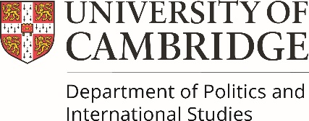

Ethics Amendment Form
Use this form if:
- The ERF committee have reviewed your ethics application and ask you to make some amendments to your application before approval can be given. Or:
- The nature of your research and/or field trip has changed and you want to make minor amendments to your original application(s).
Students, please complete the form below and return it to your programme administrator.
Staff, please return the completed form to erf@polis.cam.ac.uk
Name
Programme/Staff
Department/Centre
Academic Year (students)
Date original application was approved

Ethical Approval

Signed:

Date:

For Office use only
Date of initial review
Name of reviewer
Amended information submitted (Yes/No)
Approved (Yes/No)
Date student informed

